Tutorial 6.2: Security Testing
In this tutorial, you will be researching various security tools.

- Research on Security Testing
- Describe the different types of security testing you can perform.

- Research at least 3 different software tools you can use for security testing. Provide a brief writeup on the selected tools and provide a comparative analysis for these tools.

- Security testing with Python Bandit

Bandit is a tool designed to find common security issues in Python code. To do this, Bandit processes each file, builds an AST from it, and runs appropriate plugins against the AST nodes. Once Bandit has finished scanning all the files, it generates a report.
More information can be found at https://bandit.readthedocs.io/en/latest/

Instruction to install Bandit can be found here:
- https://bandit.readthedocs.io/en/latest/start.html

- After installing Bandit, you are now ready to perform some security test.
  - Download the webapp.py file into your project directory.
  - Run the command in your terminal: bandit -r webapp.py
You will see the following:
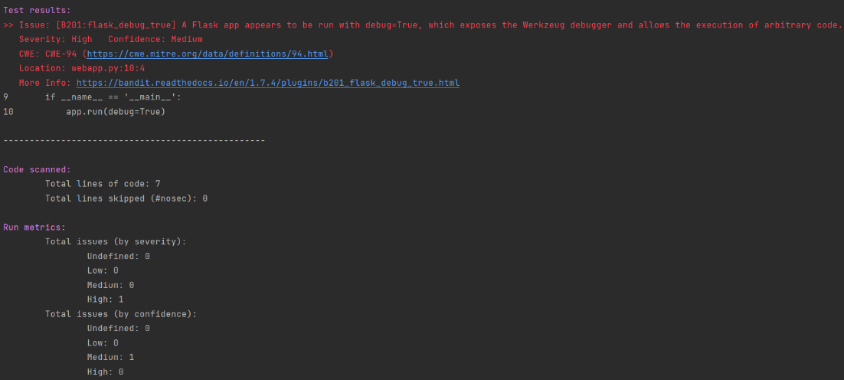
This shows the code has 1 security issue with high severity with medium level of confidence.
  - You can also export this report using the command:
bandit -r webapp.py -f json -o C:\Users\kyeo\output_file
Output File Location
Output File name
Output format

- Next, go to https://github.com/PyCQA/bandit/tree/main/examples to test out how Bandit works. Select any files from the link and run Bandit to check out their security status.

- Security Testing with OWASP ZAP
Zed Attack Proxy (ZAP) is a free, open-source penetration testing tool being maintained under the umbrella of the Open Web Application Security Project (OWASP). ZAP is designed specifically for testing web applications and is both flexible and extensible.
To get started, go to https://www.zaproxy.org/getting-started/
- Read more about how this software works
- You can download the software
- Instructions on how you can use the software
Please note:
Before we start any security test, we need to be careful that we have the permission to test live websites. Another way to get round this problem is to host the website on your own computer. To do that we can use XAMPP.
XAMPP is a cross-platform web server that is free and open-source. XAMPP is a short form for Cross-Platform, Apache, MySQL, PHP, and Perl. XAMPP is a popular cross-platform web server that allows programmers to write and test their code on a local webserver. To put it simply:
- XAMPP is simply a local host or server.
- This local server runs on your personal computer, whether it’s a desktop or a laptop.
- It is used to test clients or websites before publishing them to a remote web server.
- On a local computer, the XAMPP server software provides a suitable environment for testing MYSQL, PHP, Apache, and Perl projects. Because most real-world web server deployments share the same components as XAMPP, moving from a local test server to a live server is straightforward.
To download XAMPP, go to https://www.apachefriends.org/
You can also find a tutorial on installation with step-by-step instructions on https://www.ionos.com/digitalguide/server/tools/xampp-tutorial-create-your-own-local-test-server/
Now you are ready to host your website locally. Keep Apache and MySQL running.
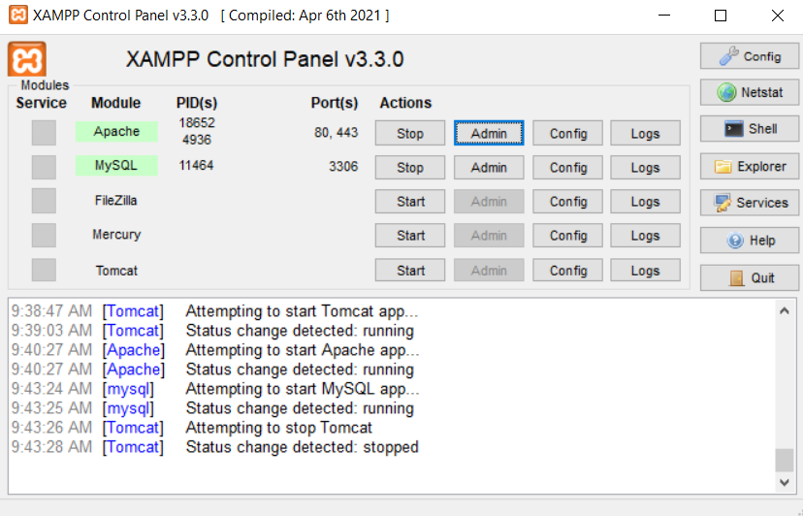
Tasks:
- Go to https://code-projects.org/c/languages/project/phpprojects/. Find any suitable project and follow the instructions. You can even find a YouTube video link.
- Host the website locally on your own computer. Open a web browser and type in: localhost/loginsystem/login.php
An example is shown below for the Login Registration System:
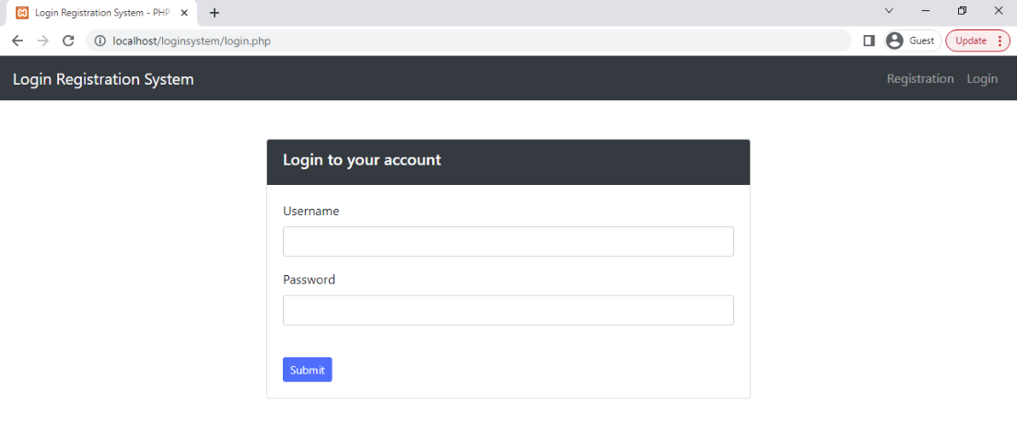

- You can now run ZAP automated scan on http://localhost/loginsystem/login.php. You need to change the URL link based on the project you have downloaded.
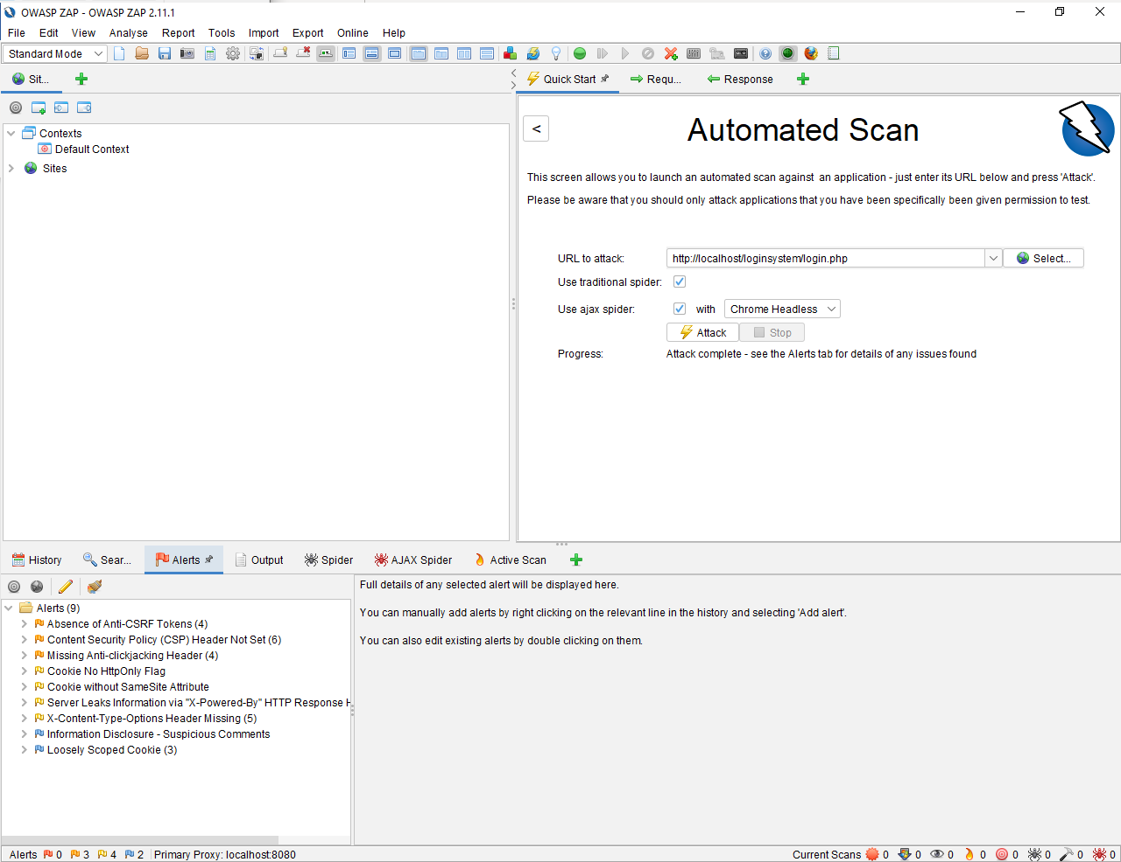

- Click on Alerts and you can check the 3 medium priority alerts, 4 low priority alerts and 2 informational priority alerts. You can also view more details on the alerts on the risk level, confidence, source and solutions.
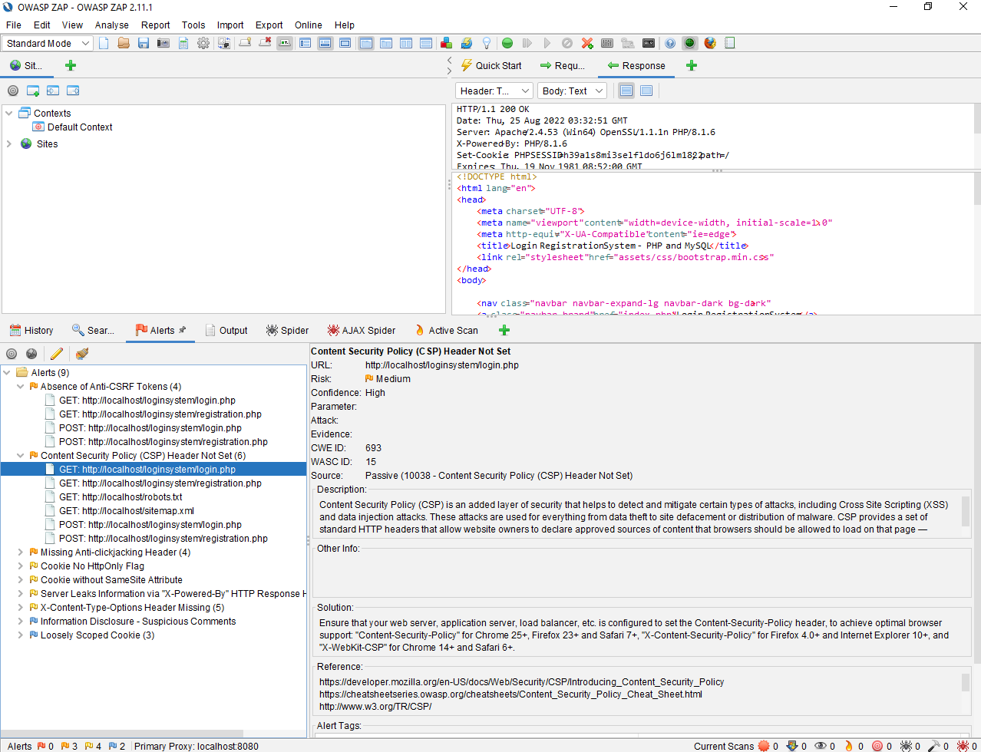

- You can now try out other php web applications and explore more usage from ZAP.

Useful resources:
Video
- OWASP ZAP For Beginners https://www.youtube.com/watch?v=wLfRz7rRsH4
- OWASP ZAP Demo finding vulnerability using ZAP https://www.youtube.com/watch?v=2kaha1J-cQo
- Brute Force (low/med/high) – DVWA https://www.youtube.com/watch?v=SWzxoK6DAE4&t=279s

Other useful tools
- Guardrails https://www.guardrails.io/
- Burp Suite https://portswigger.net/burp

